

# Objective

You will install a wiki software for your web server, learn to use Linux documentation, very basic user administration, a simple shell script and explore the cron job scheduler utility.

您将为您的web服务器安装一个wiki软件，学习使用Linux文档，非常基本的用户管理，一个简单的shell脚本，并探索cron job scheduler实用程序。

1. **Take snapshots of VMs**

Before you start the VMs and do further work on them, take a snapshot for each of them. A snapshot saves your current VM with all your programs, configurations and files. You can revert a VM to any of snapshots as you need at a later time.

To create a snapshot, click at the **Take** icon from the Snapshots pane under Machine Tools. Give

**Lab 1** as the Snapshot Name.

(*You can also take a snapshot from the menu of the VM.*) Do it for both VMs

Please remember to take snapshots at the beginning of all labs and name them as **Lab 2**, **Lab 3** etc, respectively. There will be no instruction in the lab spec to do so in subsequent labs and it is assumed you would have done so.

在启动虚拟机并对其进行进一步操作之前，请为每个虚拟机拍摄快照。快照将保存当前VM以及所有程序、配置和文件。您可以在以后根据需要将VM还原为任何快照。

要创建快照，请单击机床下快照窗格中的拍摄图标。给予

实验室1作为快照名称。

（您也可以从VM的菜单中获取快照。）对两个VM都执行此操作

请记住在所有实验室开始时拍摄快照，并分别命名为实验室2、实验室3等。实验室规范中没有关于在后续实验室中进行此操作的说明，并且假设您已经这样做了。

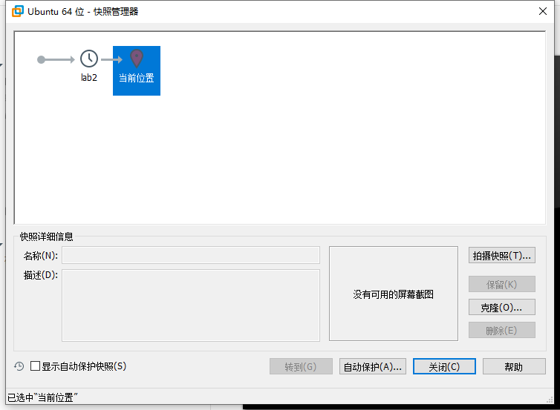

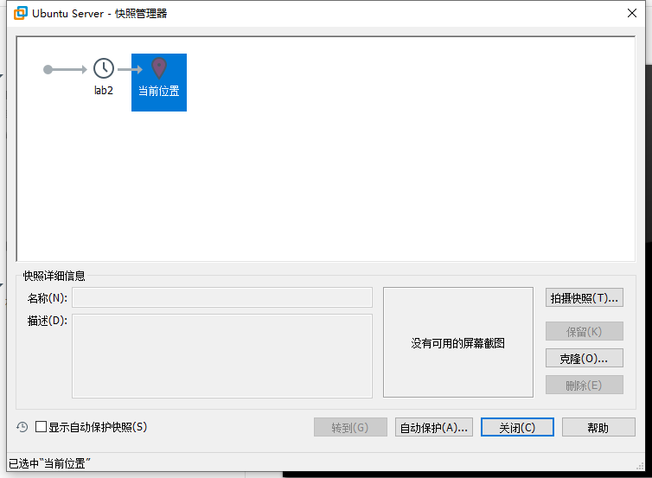

1. **Install DokuWiki**

DokuWiki is a simple Open Source wiki software that does not require a database, which is an administrator's favorite. We will use it as our knowledge base and notebook for documentation.

Download the newest release from the DokuWiki.

DokuWiki是一个简单的开源wiki软件，它不需要管理员最喜欢的数据库。我们将使用它作为我们的知识库和记录本。

从DokuWiki下载最新版本。

cd /tmp

wget <https://download.dokuwiki.org/src/dokuwiki/dokuwiki-stable.tgz>



Unpack the distribution tarball.

tar -zxvf dokuwiki-stable.tgz

Move all files to the webspace.

sudo mv dokuwiki-*/ /var/www/html/dokuwiki

sudo chown -Rh www-data:www-data /var/www/html/dokuwiki

Now point your browser on the *desktop* to *serverIP/dokuwiki* and you should see a Dokuwiki page with a message: "**This topic does not exist yet**".

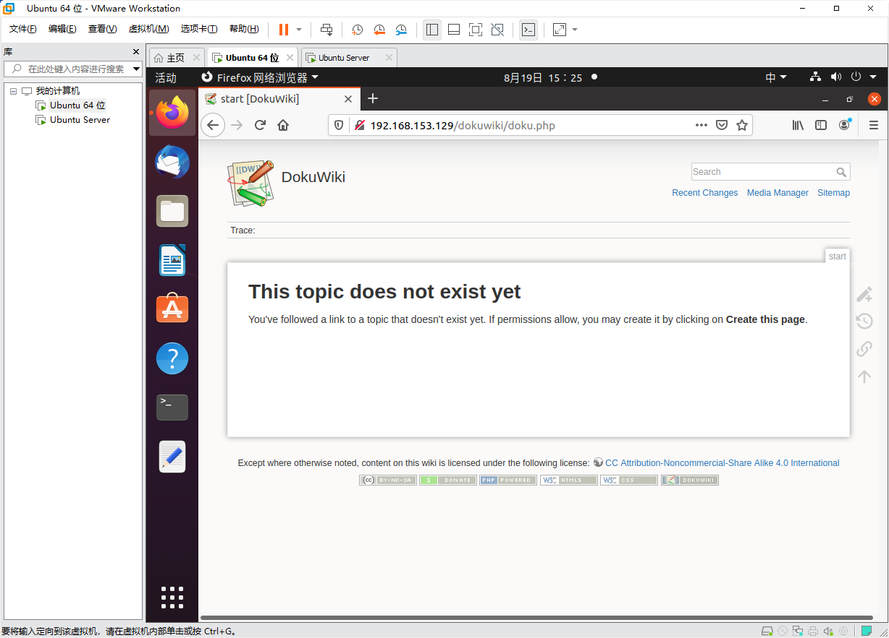

Follow the instruction on the page to create a new page with the following content:

====== *YourName*'s Wiki ======

Created for the lab

Save the page.

爷就是不落窠臼

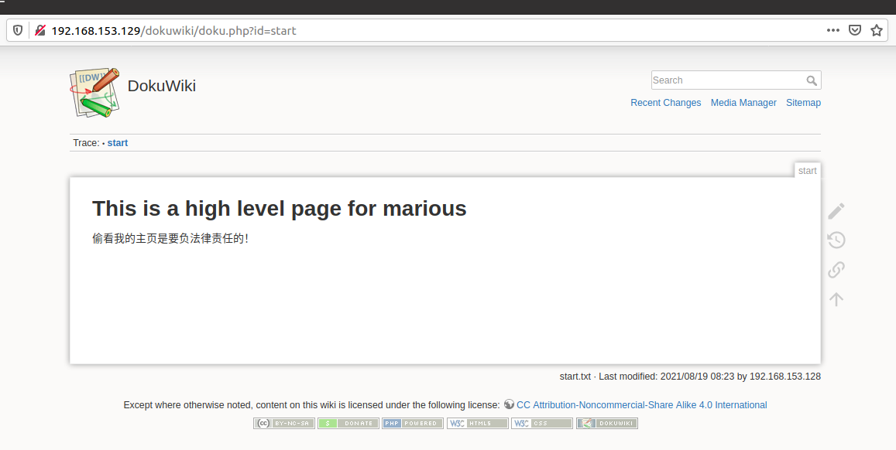

Useful information:

Tips on syntax: https://www.dokuwiki.org/wiki:syntax User manual: [https://www.dokuwiki.or](http://www.dokuwiki.org/manual)g/manual

1. **man pages**

sudo apt-get install manpages-dev

All common commands under Unix should have what is referred to as a “man page”. Nothing to do with Fathers’ Day, “man” is short for “manual”, as in reference manual. These man pages have a well-defined format, but it may take you some time to get used to it. For now, just know that you can find some documentation about each command.

Unix下的所有常用命令都应具有所谓的“手册页”。与父亲节无关，“男人”是“手册”的缩写，就像参考手册一样。这些手册页具有定义良好的格式，但您可能需要一些时间才能习惯。现在，只需知道您可以找到关于每个命令的一些文档。

So to see the information on the “chown” command, you would type:

man chown

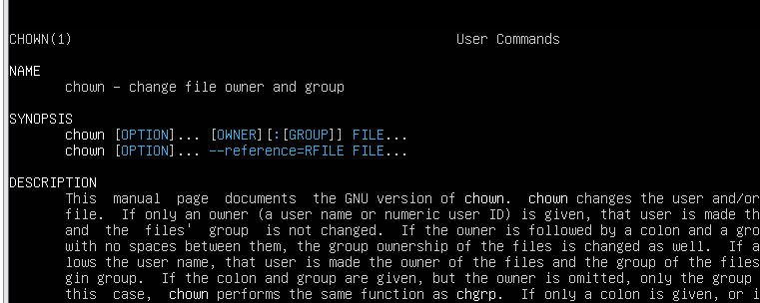

Note towards the end (you can scroll up and down) there is a section called SEE ALSO that mentions chown(2). This is to say that there is another section in the manual that may tell you something different about the command. So to read the section 2 entry for chown instead of the default page, type

注意在结尾（你可以用空格滚动）有一个叫做SEE的部分提到了chown（2）。也就是说，手册中还有另一部分可能会告诉您有关该命令的一些不同内容。因此，要阅读chown的第2节条目而不是默认页面，请键入

man 2 chown

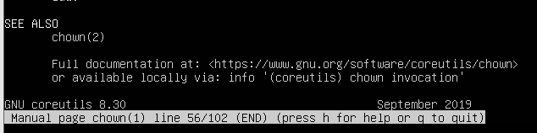

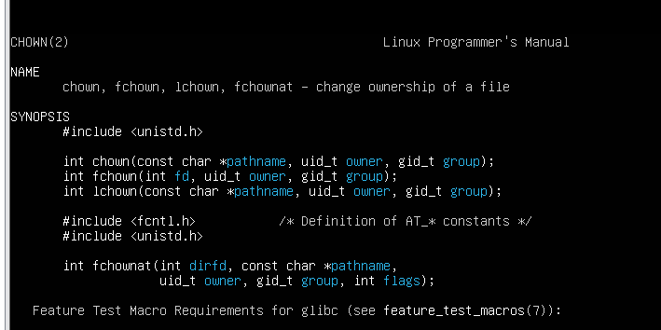

If you want to know in which section you might find a certain kind of command, that information is listed in the man page for man.

(Yes, even the man command has a man page.)

如果您想知道在哪个部分可以找到某种命令，该信息将列在man的手册页中。

（是的，甚至man命令也有一个手册页。）

man man

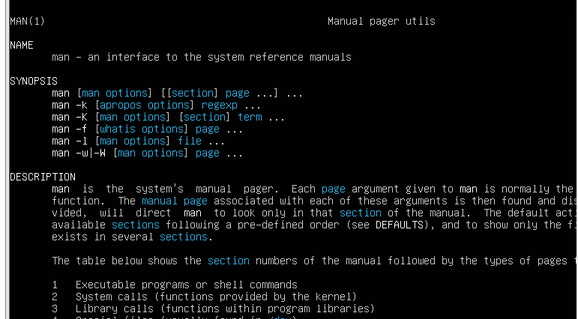

*Question: What kind of documentation does Section 3 typically contain?*

*sudo apt-get install manpages-posix-dev*

*第3节通常包含哪些类型的文档？man 3 chown*

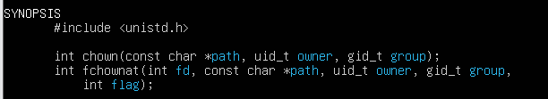

*chown函数的调用*

If you don't know what the exact name of the command is, you might be able to find it with the –k

option (key word)

如果您不知道该命令的确切名称，您可以使用–k找到它

选项（关键字）

man –k user

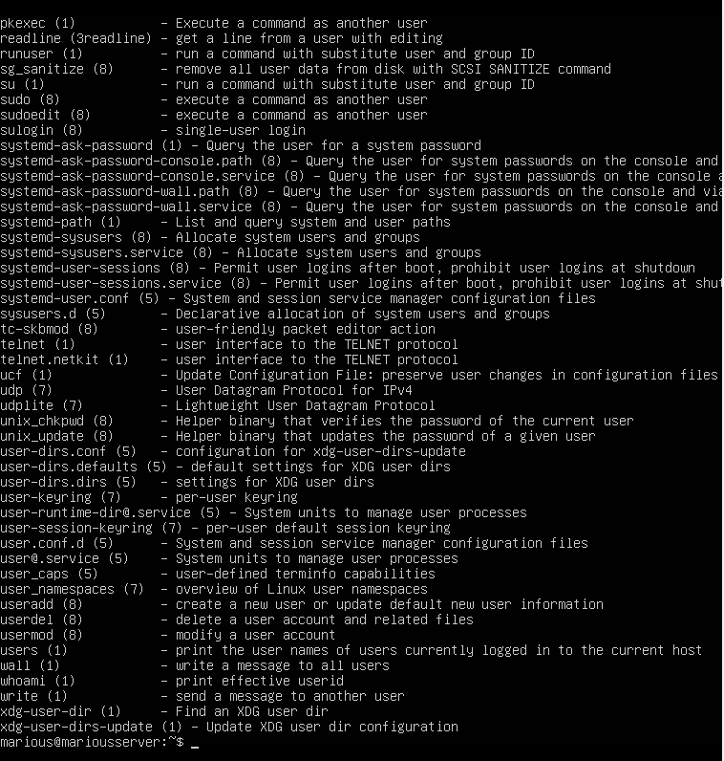

Note that this approach sometimes gives too much data back. It is a simple text match, so if you want to know about pages containing the word cat, you will also be suggested pages that contain words *containing* cat, like **allocate** and **certificate**.

请注意，这种方法有时返回的数据太多。这是一个简单的文本匹配，因此，如果您想了解包含单词cat的页面，还将推荐包含单词cat的页面，如allocate和certificate。

1. **Users and groups**

When you originally installed your VM, you added a single user with which to access it. That user has a username and password and other attributes. How do you add more (from the command line)?

最初安装VM时，您添加了一个用户来访问它。该用户具有用户名、密码和其他属性。如何（从命令行）添加更多内容？

sudo useradd testuser



等他反应过来，输密码



Oops, I meant test1. Let’s delete the account that was just created.

让我们删除刚刚创建的帐户。

sudo userdel testuser



But I now want 5 accounts: test1, test2, test3, test4 and test5.

What if I wanted 50 or 500 new accounts… should I do that kind of thing by hand??? Absolutely not. It should be scripted.

So let's create a script:

cd /tmp; pico testaddusers.sh

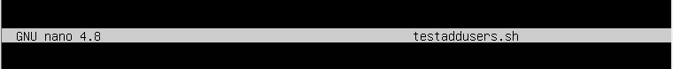

Type in the following script:

#!/bin/bash

for (( i=1 ; i< 6 ; i++ )); do sudo useradd test$i;

done

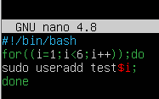

Save and exit (^X).

ctrl x

Now adjust this file so that only the root user can utilise it.

sudo chown root testaddusers.sh sudo chmod 700 testaddusers.sh



And run it!

sudo ./testaddusers.sh

To see signs of the positive result :

tail /etc/passwd

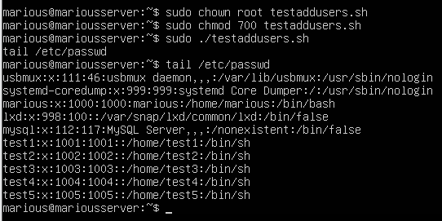

Now we want to add a special group for users called shark. sudo addgroup shark

To see signs of the positive result:

tail /etc/group

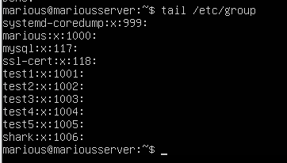

And we want to add some users to the group, but we don't want to change their primary group! So instead add a supplementary group membership to two users:

sudo usermod -a -G shark test3

sudo usermod -a -G shark test4

Who is in the shark group now?

grep shark /etc/group



1. **cron**

What if I wanted to run a regular report, telling me who was in the shark group? Instead of running the above report by hand, what if I wrote the answer into a file that I could check at any time? cron

is a time-based job scheduler running as a system daemon that runs commands at specific times designated by you. (For one-off tasks, consider at instead.)

如果我想做一个定期报告，告诉我谁是鲨鱼组的成员呢？如果我不手动运行上述报告，而是将答案写入一个可以随时检查的文件，该怎么办？

cron是一个基于时间的作业调度器，作为系统守护进程运行，在您指定的特定时间运行命令(对于一次性任务，请考虑。

To edit your crontab:

crontab -u abc123 -e

(Select the default editor nano which is a clone of pico.)

and add the line to the end:

* * * * * grep shark /etc/group 2>&1 > /tmp/sharks

* The 5 asterisks are important. They define times. 其中 f1 是表示分钟，f2 表示小时，f3 表示一个月份中的第几日，f4 表示月份，f5 表示一个星期中的第几天。program 表示要执行的程序。

You can be more specific than ‘every minute’ though. See the following reference for details:

https://help.ubuntu.com/community/CronHowto

minute (0-59), hour (0-23, 0 = midnight), day (1-31), month (1-12), weekday (0-6, 0 = Sunday).

To list what cron jobs you have in the system:

crontab –u abc123 –l

( The last letter l is the letter l, not number one 1)

Once you have that working, alter the cron job to only report at 9am on a Monday.

周一见（

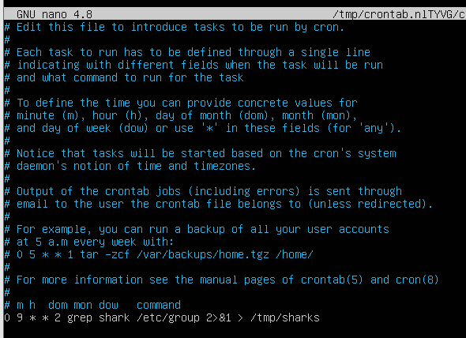

# Submission and mark

For full marks today, show your teacher

1. your first new wiki page of Dokuwiki
2. your answer to the "Section 3" question for man command;
3. your altered crontab entry;条目

0 9 * * 2

1. the contents of the file /tmp/sharks.





6 marks for all 4 items above;

3 mark for 3 items, missing any one of 4 items above; 0 mark for all other than above.

You should be ready to answer any questions to demonstrate that all work is done by yourself otherwise you may receive 0 mark.

# IMPORTANT NOTE: You will need to document all of your lab work in your wiki. Organising your page by creating a link for each lab. You document what you have done and learned in labs. Creating a list of commands you have used in labs with excerpts from man pages. You can do this task after the class.

您将需要在wiki中记录所有的实验室工作。通过为每个实验室创建链接来组织您的页面。您可以记录您在实验室中所做和学到的内容。使用手册页的摘录创建实验室中使用的命令列表。下课后你可以做这个任务。